Yovanny Henao

Tuan Le

Instructions for flixRush App

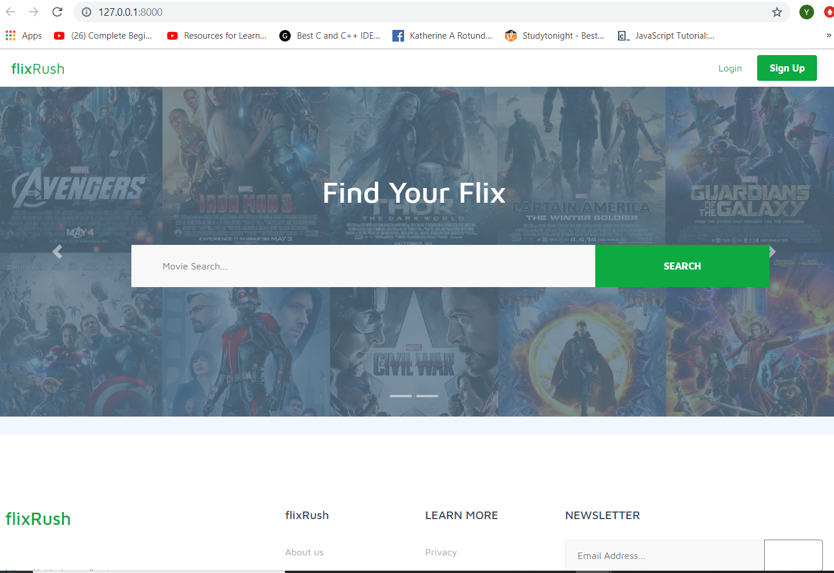

The web application ‘flixRush’ has a movie & TV show search engine. Users that are registered with the site have the privilege to see their search results displayed in a organized template format on flixRush and get in depth information about their movie/show. Users that are not registered can still search for movies/shows but will not be able to see the customized detailed format of specific movies. They have the option to going to IMDB to see some details about their search. If they click anywhere else, they will be redirected to a log-in page. The application encourages new users to register so that they may enjoy full access.

What is needed:

- Pycharm (installed)

- Django (installed)

- Python (version 3.6 and above)

Production Link: <https://flixrush.herokuapp.com/>

Github Link - <https://github.com/HeyTY/flixrush-app>

Superuser Login:  adminsuper , password#123

Pycharm or an IDE like it is needed to open the project folder. Make sure your IDE is updated and has Python installed. It’s recommended that Django be installed directly on to your local computer or you can use the feature on Pycharm that accesses Django. If you go with the latter option; open a ‘new’ project, click on Django icon. Make sure the radio button is clicked for the use of the virtual environment feature.

Once the project is opened, use the terminal to run the server (or go to ‘Tools’ tab and click ‘Run manage.py task’). The local address link should appear and then click on it.

On the home page (index.html) there is a search text field where users can make search queries.

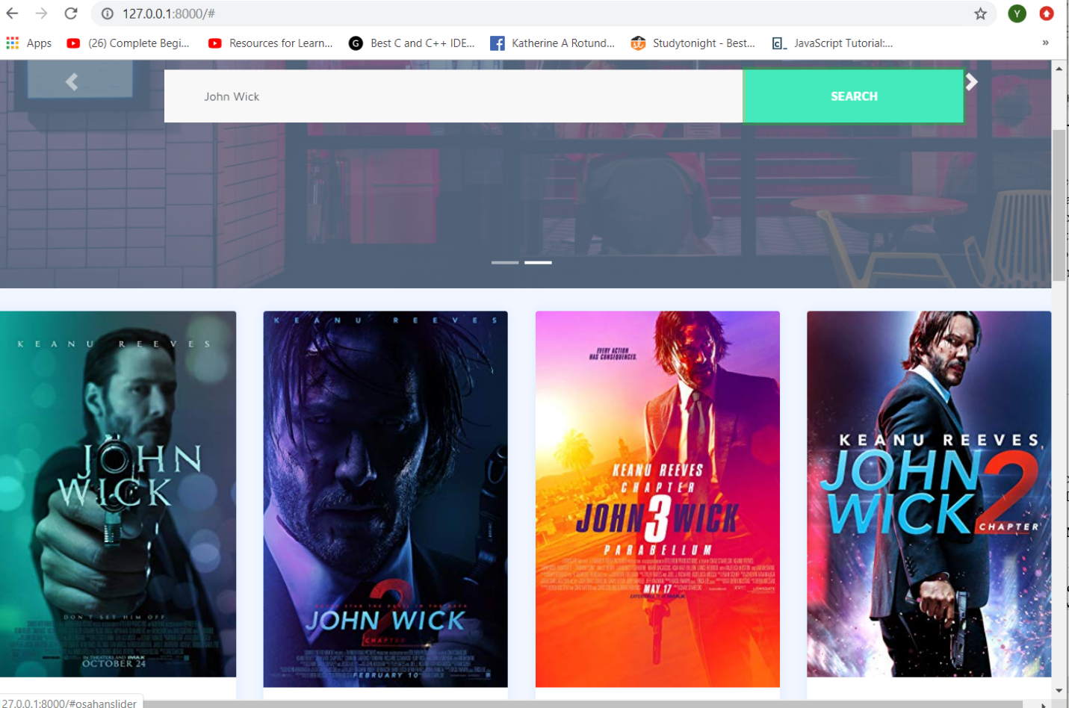

A list of ten movies is returned relating to the search query sent. Behind the scenes, an AJAX call is made to OMDB that returns an array of movies

When the results populate the home page, registered users will be able to click on the images for more details. Users that are not registered will be redirected to a log-in page.

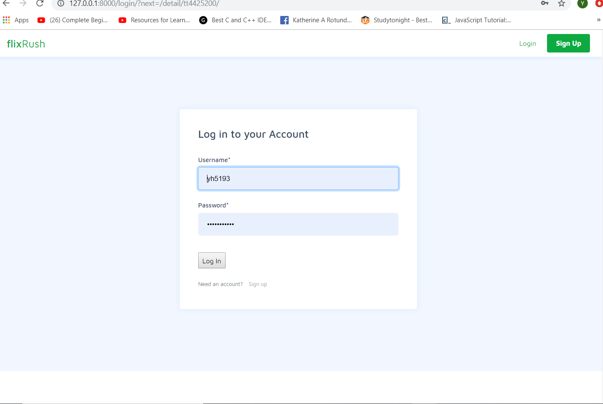

If users do not wish to register with the application, they can click on the link to IMDB (below movie poster) and access their services.

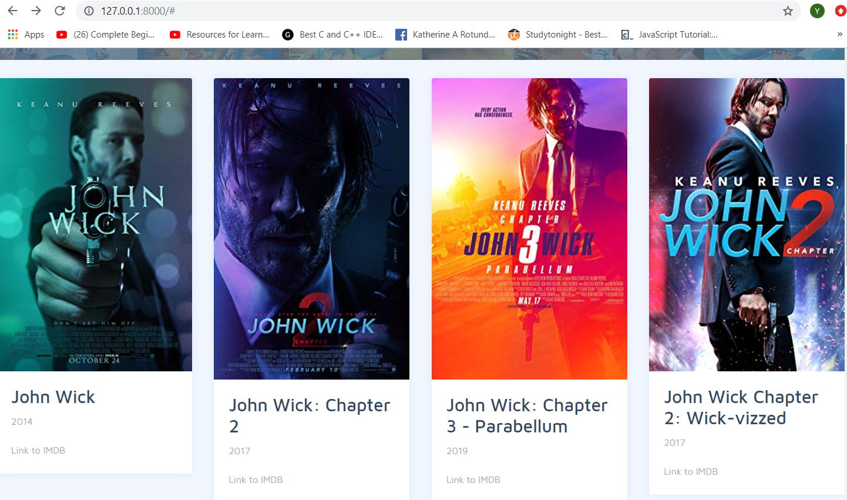

Our application provides a customized search experience and encourages users to register for our service.

For registered users, detailed information is provided about a show/movie. Details such as :

**'Title'**: movie[**'Title'**],

**'Year'**: movie[**'Year'**],

**'Rated'**: movie[**'Rated'**],

**'Runtime'**: movie[**'Runtime'**],

**'Released'**: movie[**'Released'**],

**'Genre'**: movie[**'Genre'**],

**'Poster'**: movie[**'Poster'**],

**'Plot'**: movie[**'Plot'**],

**'imdbRating'**: movie[**'imdbRating'**],

**'Awards'** :movie[**'Awards'**],

**'Language'**: movie[**'Language'**],

**'Country'**: movie[**'Country'**],

**'Actors'**: movie[**'Actors'**],

**'Writer'**: movie[**'Writer'**],

**'Director'**: movie[**'Director'**],

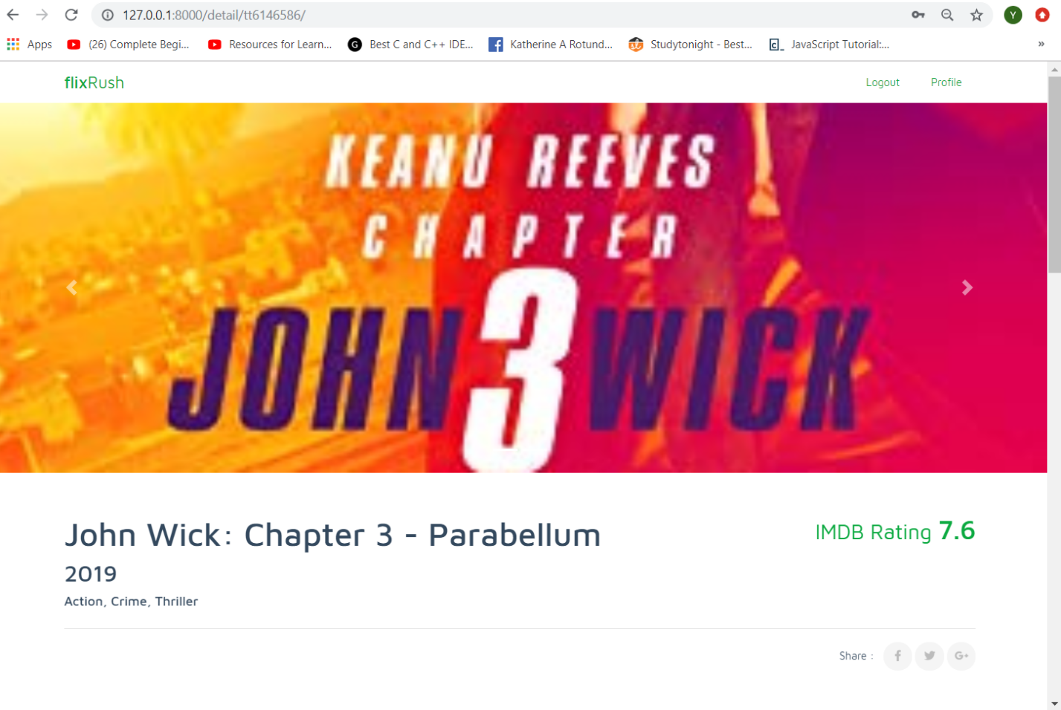

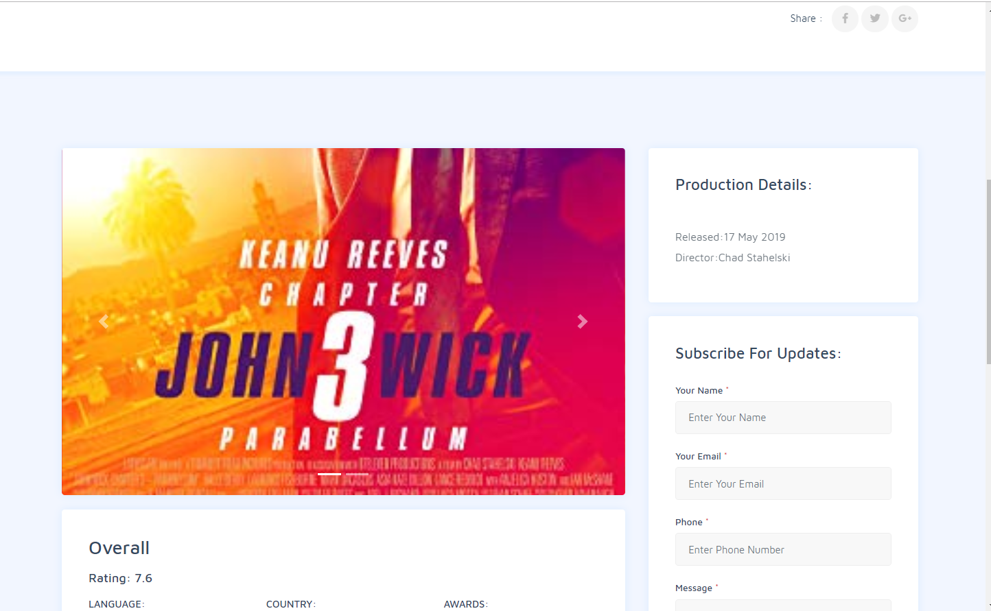

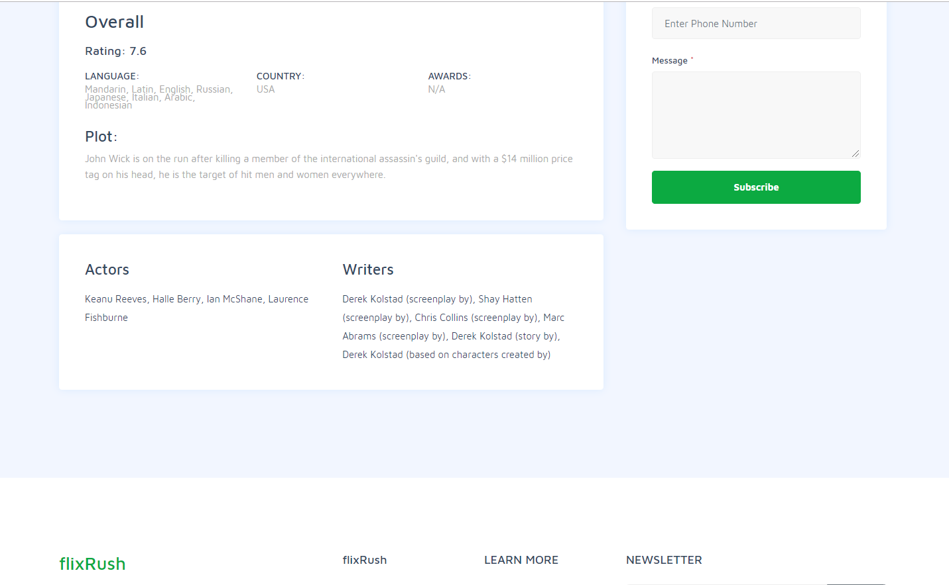

The data to create this detailed is made by making another API call to OMDB. In this instance, one JSON is received that has the detailed information of the movie. It is then saved as a variable. When the detailed.html page appears; the template is populated with the data received from the second API call. The movie objects details fill up the page.

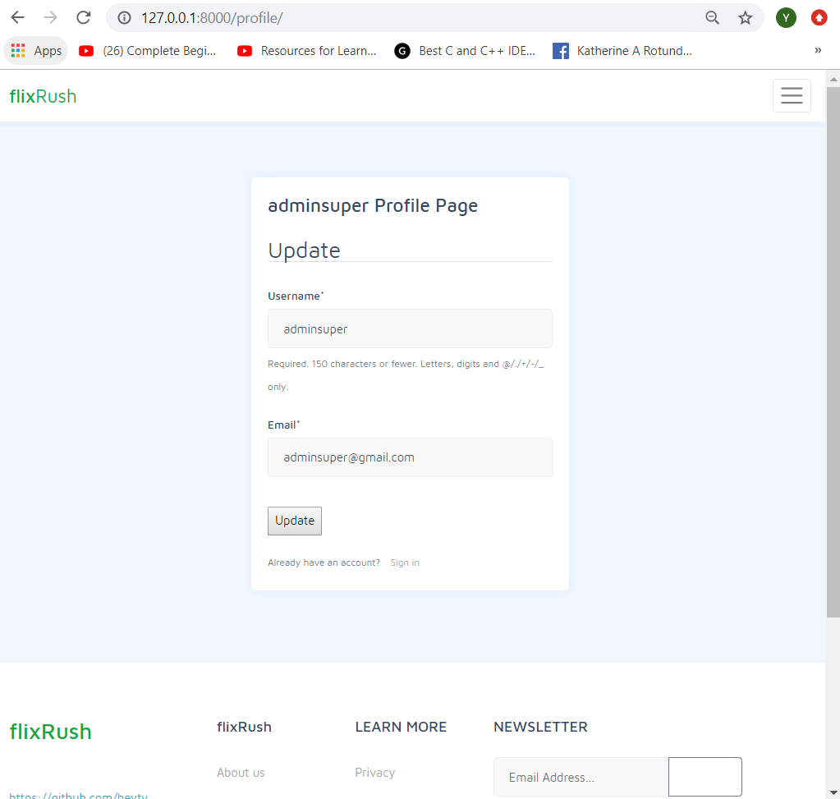

In order to access the profile page, a user must be logged in. This privileged access gives the user the opportunity to update their credentials (username/email). User’s cannot change a username or email to an existing one that resides in the database. Validators are in place to check for this logic.